Why is Skateboarding so Popular?
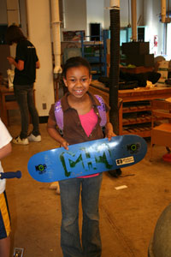
Skateboarding is a popular sport, with an estimated 18.5 million skaters worldwide. What is it that makes this activity so popular?

One reason for skateboarding's popularity is because it can be done anywhere: inside, outside, in large spaces or small areas. While skateparks may offer the most ideal places to skateboard, a skater can skate anywhere; skaters can skate wherever they are.

Another explanation for skateboarding's popularity is the relatively low price of equipment. Anyone with a pair of trainers can pick up a skateboard for less than £50 and begin riding, learning, and enjoying the act of skating. Therefore, the low cost makes skateboarding available to anyone and everyone.
Possibly the most obvious reason for skateboarding is physical fitness. Skateboarding is good exercise. A skater must use their entire body just to balance, push, and propel themselves forward on a skateboard. Skateboarding works to build cardio and core strength, improve flexibility, and fully develop balance and coordination skills. This results in skateboarders being as fit as any athlete. This is a good reason to take up this sport.

The final reason for skateboarding's popularity is that it is the ideal crossover sport for other board sports, such as surfing, snowboarding, or wakeboarding. If the waves are flat, the snow is melting (or the water is too cold), a person can help keep their skills sharp and fitness levels up by simply riding a skateboard.
Skateboarding at a glance:

- flexible
- low cost
- active

Skateboarding: how to get started
Parts of a Skateboard
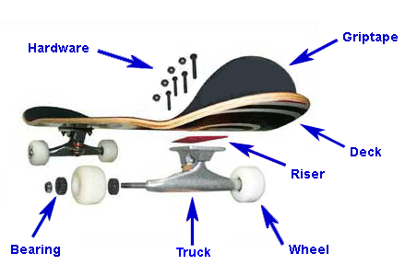
If you're an absolute beginner and you've never set foot on a skateboard before, then there are a few things you should know before you start.

1. Set Up Your Skateboard
Choose an inexpensive skateboard at first. Firstly, good skateboards are surprisingly expensive, and if you end up not wanting to skateboard buying one is going to be a waste of money. Secondly, they are a lot faster which makes them harder to ride and less forgiving.
Loosen your trucks because new skateboards tend to have them done up very tightly. Although this is very stable, you won't be able to turn your skateboard at all and if there is a natural lean to the board (there usually is) you'll end up riding in to a wall.

2. Work Out Your Stance
Work out how you stand on your board. If your left foot is forward, or you are facing to the right you are in the position called "regular". If your right foot is forward, or you are facing to the left you are in the position called "goofy". For most people, they stand with their writing hand facing backwards and their opposite foot forwards.

3. Push Off
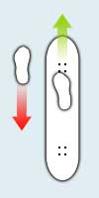
Push off up a shallow hill or on a level surface. You should imagine that pushing off is like walking; your pushing foot must step in front of the foot on the skateboard and then push back, just like taking normal steps.
Take a couple of long, smooth pushes to gain some speed. Getting on requires you to twist the foot that is on the board around to face sideways instead of forwards and step backwards onto the back fishtail. Step on firmly and confidently and don't mess about as this is when you are most vulnerable to falling off. Your feet should be behind the bolts in both cases, so if you don't get into this position straight away, try to quickly shuffle into the correct position.
Foot Positioning to Push Off

The Science behind the Ollie
Invented in the late 1970s by Alan ‘Ollie’ Gelfand, the ollie has become the basis for many other more complicated tricks. In its simplest form, the ollie is a jumping technique that allows skaters to hop over obstacles and onto curbs. Have you ever wondered how an ollie works?
How Forces Act in an Ollie
There are three forces that come into play as the skateboarder rides forward on his or her skateboard. These forces are the weight of the rider pressing down on the board, the effect of gravity pulling down on the rider, and the forces of the ground pushing up.
- When a skateboarder decides to perform an ollie, the first step is to crouch down slightly. This helps the skateboarder jump and accelerate upward.
- Then the skateboarder presses down with his or her rear foot, sharply, on the tail of skateboard. This causes the skateboard to flip up. The ground pushes back against the board and results in a rotation movement.
- As the board is rotating, the skater drags his or her forward foot up along the board. This causes the board to tilt up higher.
- The skater then pushes down with his or her forward foot on the front of the board, while pulling up on his or her rear foot to get out of the way of the rotating board. The skater and the board are level at this point and because of this look stuck together.
- Finally, gravity pulls the skater and the board back to the ground.

A | B | C | D

Skateboarding requires the manipulation of forces to achieve a range of moves and tricks. Who thought forces could be this much fun!

accelerate: begin to move more quickly
force: a push or pull
gravity: a force which pulls two objects together (the Earth's gravitational force pulls objects towards the ground)
ollie: a jump performed without the aid of a take-off ramp

Spotting
Spotting is a technique used by dancers when turning in order to reduce feelings of dizziness. These steps will take you through the process.
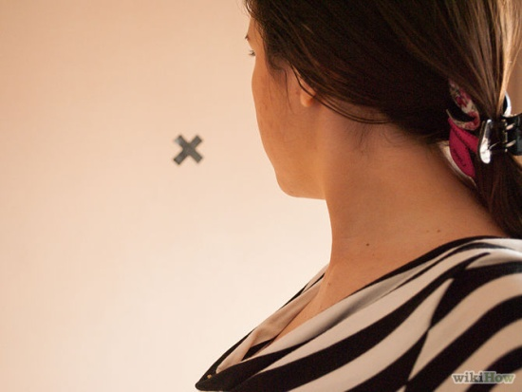
First, find a 'spot' on the wall in front of you, perhaps a mark, a fixture or you can even place some tape on the wall and make your own mark.
Next, stand up straight with your hands on your shoulders. Begin by slowly turning to the right whilst continuing to keep your head focused on the spot. Having your hands on your shoulders assists your balance, so later on when you have practised a lot you can bring your arms out to the side.
When you have turned your body as far as you can, your head will also need to turn; this is around the point where your chin is over the top of your left shoulder. You will also know when you have got to this point as you won't be able to keep your focus on the spot anymore and naturally your body will want to move your head.
As you continue to turn your body to the right, whip your head around and focus back on the spot again. Your head will now be facing more to the left then your body is and then just let your body follow your head back to your starting point.
Good luck!

Safety Considerations:
- Do not wear socks. If you are an amateur dancer and don't have the correct footwear then just do it barefoot to prevent injury;
- Do not do this on a rug as you will trip over. Use a hard floor; and
- Make sure you do not look at your spot for so long that your neck hurts.

When you spin, why do you get dizzy?
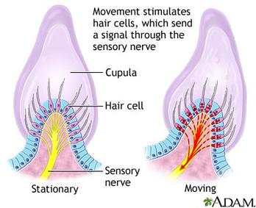
The ears have two functions. In addition to hearing, the ears have another important purpose. The inner parts of the ears give a sense of balance and this text will explain how.

The inner parts of the ear are open spaces filled with fluid; this fluid is called endolymph fluid. The inside walls of the spaces are covered with tiny hairs. Each hair is connected to a nerve cell that carries signals to the brain, along the sensory nerve.

When the head moves, this causes the fluid to slosh around and bend the hairs. As each hair bends, it makes its nerve cell send a signal, telling the brain about that movement.

When we spin around, the fluid starts spinning too. That gives us the sensation of spinning. When we stop, the fluid keeps moving (and bending tiny hairs and signalling the brain). Because the fluid is still moving, the nerve cell continues to send a 'movement signal'. This means that we feel that we are spinning, even though we are now still. We call that ‘feeling dizzy’.

Glossary
cupula a gel-like cap surrounding hair cells
endolymph fluid fluid found in the ear
nerve cell cells which carry information
sensation something we feel
sensory nerve a nerve which transmits information about sensations

