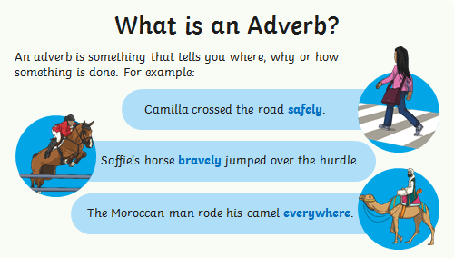

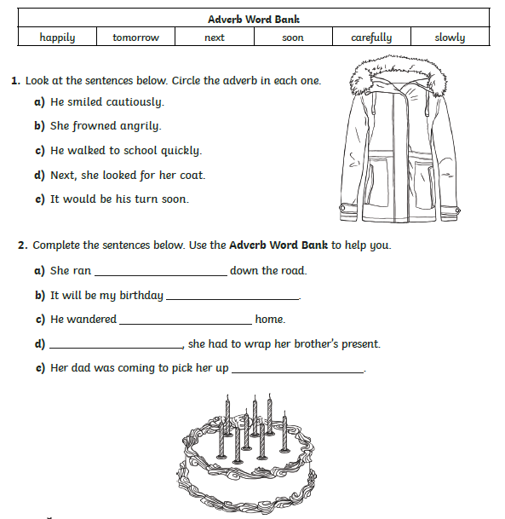

Using Different Types of Conjunctions

Coordinating Conjunctions
and but or so

Subordinating Conjunctions
although because so that even if whenever before even though until

Use a coordinating conjunction to rewrite these pairs of sentences as one sentence.
- We enjoy watching films. We enjoy going bowling.
- He wants to win the race. He is running more slowly than the others.
- My mum loves cake. I am going to bake a cake for her birthday.
- I went to bed very late. I am tired today.
Use a subordinating conjunction to rewrite these pairs of sentences.
- My hands are freezing cold. I forgot to bring my gloves today.
- My mum takes me to the match every week. She doesn’t like football.
- I take the dog for a walk every day. Sometimes it is raining.
- My dad has fixed my bike. I can take it to the park.

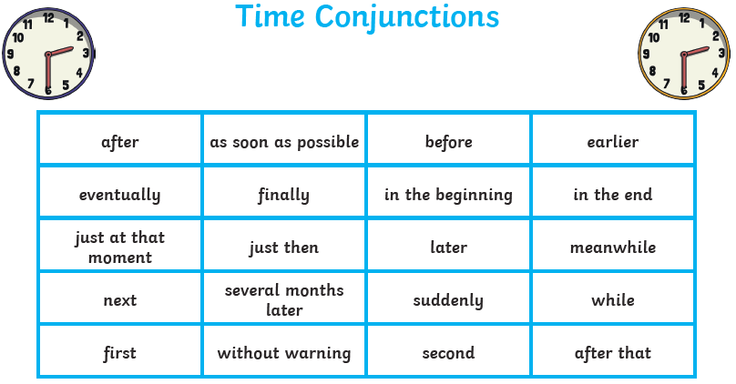

Use the time conjunctions to write sentences about your weekend.
Think about the order you will use them.

