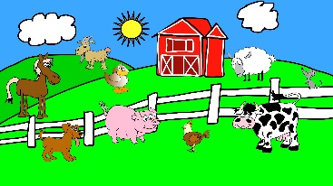
OWLETS HOME LEARNING
Summer 1st Half 2016
FARMING

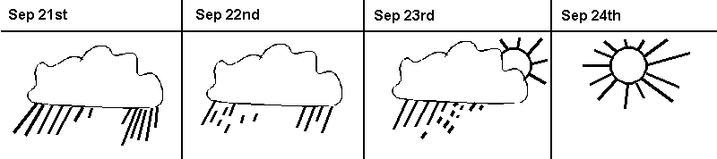
The regular activities are to be completed by all children. The spellings will continue to be tested every Monday morning and the mental maths will be tested on Thursday mornings. The practise sheets are dated and we will let you know if they are not tested for any reason. We ask all children to complete the core task and bring it to school on Friday 27th May. The optional activities are a list of suggestions that you can do at home if you wish. They can be done at any time. We do not require these to be handed in, although if your child would like to show their work please feel free to bring it to school on any Friday. We will ensure all work is shared with the class and the children will receive team points for completing them. We would like to ask you to ensure your child brings topic related show and tells to the class.
Optional activities
- Make a map such as, a journey to school, a walk or how to get the shop.
- Make a compass.
- Find out about farming in the past and compare to the present.
- Keep a tally chart of different farm animals or machinery that they may see.
- Draw and label farm animals.
Core task

Challenge: Create a weather diary.

This can be displayed to the class in a variety of ways. For example, PowerPoint, a video clip, calendar or a non-fiction style book. Your weather diary could have information about how the weather you see effects farming in the community.

Regular activities to do at home
- Reading books. We expect children to read as much as possible and would like to see their books being changed at least 3 times a week. Please comment in their reading record, preferably related to their current target which is on the, ‘I can…’ sticker.
- Phonic Owls. Please use the flash cards on a regular basis to see whether your child can recognise the sound and name of letters. These will be updated/changed each week.
- Mental Maths
- Spellings
Please note Welly Wednesday will begin on Wednesday 20th April.

