Head of School: Miss Amy Scrivener
Administrator: Mrs Melanie Ford

01837 861361
www.bridestowe-primary.devon.sch.uk Executive Principal: Mr D.Chapman
Head of Primary: Mr M.Brady
Spring Week 7: February 29th 2016
Bridestowe Primary School | Dear Parents and Carers,  What a busy week we had last week! We apologise for any spelling or timetables that weren’t completed on Friday but this was because Mr Chapman and Mr Brady came for a learning walk and spoke to parents, pupils and staff as well as observing the teaching and learning taking place. They were very impressed with the high levels of expectations, behaviour and attitude of the learners and you should all be very proud of your children and the effort and progress they are all making.  On Tuesday, the Barn Owls children represented Bridestowe at the Castle Drogo cross country tournament. They all did incredibly well and we came 2nd in the small schools competition. These children also got to take part in activities such as fencing.  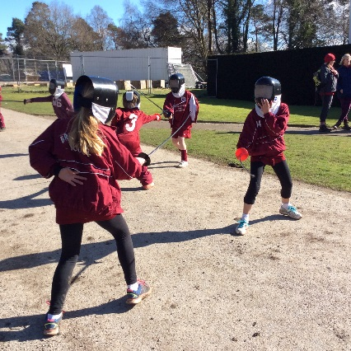  During design and technology, the Snowy Owls and Barn Owls children made a traditional Greek recipe called, Libum. They tasted food in the traditional way too and thoroughly enjoyed themselves, one of the Barn Owls said, “this is the best lesson ever”!  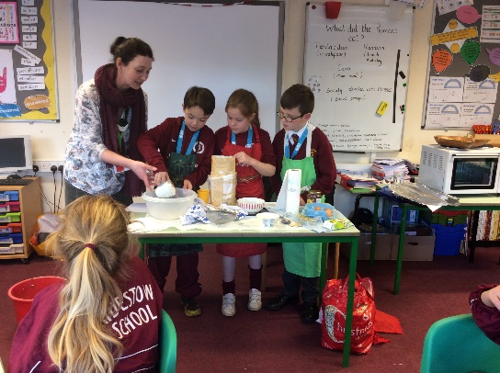  Best wishes,  Amy Scrivener

Achievement
Care and Courtesy Cup Winners:
Genevieve Hills, Harley Webber and Freya King
Worker Award:
Felix Boyson, Ayla Taylor and Grace Bird
Behaviour Award:
Jamie Horn, Amy Perkins and Holly Hewitt
Extra Awards:
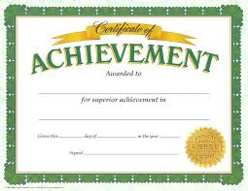
Writing Award: Ellie Cole Maths Award: Macie Haggar
Top Table Winners:
Phoenix Bruce, Samuel Palmer, Ben Cole, Ben Ford, Daniel Sullivan, Felix Boyson
Team Point Winners:
Typhoons with 42 points
Outside of School Achievements
Marley Parker was awarded a yellow belt in taekwondo with an A pass.
Diary Dates  February  29th – Football Competition  March  3rd – World Book Day  7th – Y6 Fairtrade morning  9th – Y5/6 Hockey Tournament at Okehampton 1-4pm  9th – Rock Solid FoBS Training Session, 3pm.  10th – Y6 Transition Visit from Okehampton College  10th – Federation Football/Netball Match at Chagford  14th – Parent Consultations  14th – Dan the Skipping Man (am)  16th- Parent Consultations  16th – Tag Rugby Competition at South Tawton  17th – Federation Football/Netball Match  18th – Sports Relief Fundraiser  20th – OCRA Sports relief mile  22nd – Y2 Multi-skills Festival  23rd- Music Celebration  24th – Last day of school  25th – BANK HOLIDAY  28th – 11th EASTER HOLIDAYS  April  11th – NON-PUPIL DAY  12th – Pupils Resume | Sponsored Skip  A huge congratulations to all the pupils at Bridestowe School for raising a tremendous £626.20p during their sponsored skip for the British Heart Foundation. If anybody has any outstanding money to add to this, please pass it into the office as soon as possible. This was featured in last week’s Okehampton Times with some great actions shots!
Rock Solid Training Session with Tea & Cakes!
Wednesday 9th March from 3:00pm outside Barn Owls. Come and enjoy a hot drink and a piece of cake while watching the Dugard Dare Devils (Rose & Rob Dugard, Jo & Gideon Pritchard, Sarah & Dan Quinn) complete a training session for their fast approaching Rock Solid challenge on Sunday 20th March. They are completing the 10kms, 40 obstacle challenge to raise funds for Bridestowe School and Treetops so please join us on Wednesday 9th March to show your support - sponsorship forms will be on hand!
Clubs
Netball Club
Unfortunately this will be cancelled due to Mrs Baker having other commitments on Monday 7th March.
Art Club
Unfortunately this will be cancelled on Monday 14th March due to parent consultations.
Multi Skills Club
Remember this starts on Tuesday 1st March for year 1, 2 and 3.
Reminder
Please send any parent consultation slips back to your class teacher so we can let you know your appointment times at the end of the week.
Administrator
We would like to welcome Mrs Hazel Lowden to our team at Bridestowe School as the new part time administrator. However, please note that we will not have an adult in the office on a Wednesday afternoon, Thursday and Friday until we have completed our safeguarding checks. A member of staff will regularly be checking the answer phone so please leave a message and someone will return your call as soon as possible. Thank you for your support during this time.

