Head of School: Miss Amy Scrivener
Administrator: Mrs Melanie Ford

01837 861361
www.bridestowe-primary.devon.sch.uk Executive Principal: Mr D.Chapman
Head of Primary: Mr M.Brady
Spring Week 6: February 12th 2016
Bridestowe Primary School | Dear Parents and Carers,  On Monday it was the Chinese New Year and the children have been discussing this celebration for a few weeks and creating beautiful art work which is now displayed around the school.  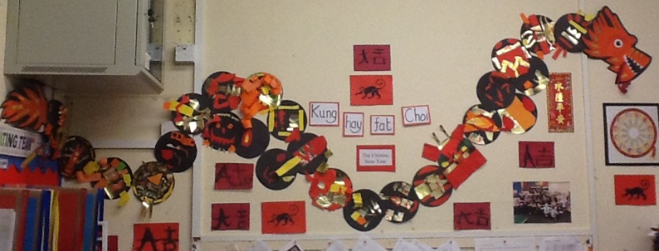  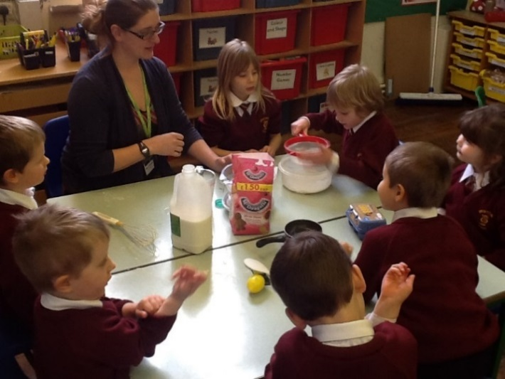  The whole school spoke about the Christian belief for Shrove Tuesday and looked at how it is celebrated around the world. The thought of the food in Iceland didn’t go down too well with the children in Bridestowe, they didn’t want to swap salted meats and peas for our traditional pancakes! The Owlets made pancakes throughout the afternoon and shared them with the whole school during assembly.  On Tuesday it was also Safer Internet Day, through the Computing curriculum, pupils took part in discussions and watched videos to help understand how to keep themselves safe whilst using this fantastic resource. This also led to discussions about keeping ourselves and others safe in school, and it was good to hear that the children have an embedded understanding and ethos across the year groups.  Best wishes,  Amy Scrivener

Achievement
Care and Courtesy Cup Winners:
Ruben Miguel-Easter, Thomas Cann and Arion Anderson
Worker Award:
Emma Berry, Isaac Jolley, Kyle Piper and Ben Cole
Behaviour Award:
Emily Moss, Travis Bruce and Daniel Tossell
Sports Award:
Julia Pratt-Reichert and Arion Anderson
Extra Awards:
Writing Award: Felix Jolley, Maths Award: Mae Robinson
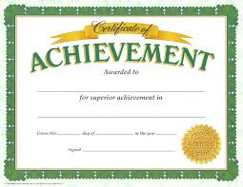
Pen Licence
Evie-Sue Ley, Grace Bird and Freya King
Top Table Winners:
Ellie Cole, Arion Anderson, Jack Yardley, Marley Parker, Korben Smart,
Daniel Tossell and Kate Dugard
Team Point Winners:
Tornadoes with 53 points
Outside of School Achievements
Evie-Sue Ley gained merit in her theatre dance exam

Diary Dates  February  15th – 21st HALF TERM  22nd – NON-PUPIL DAY  23rd – Pupils Resume  23rd – X Country at Castle Drogo  29th – Football Competition  March  7th – Y6 Fairtrade morning  9th – Y5/6 Hockey Tournament  10th – Y6 Transition Visit from Okehampton College  10th – Federation Football/Netball Match  14th – Parent Consultations  14th – Dan the Skipping Man  16th- Parent Consultations  16th – Tag Rugby Competition  17th – Federation Football/Netball Match  20th – OCRA Sports relief mile  22nd – Y2 Multi-skills Festival  23rd- Music Celebration  25th – BANK HOLIDAY  28th – 11th EASTER HOLIDAYS  April  11th – NON-PUPIL DAY  12th – Pupils Resume | Times Table Rock Stars - webpage or app  Pupils in year 2 to year 6 have been allocated a login as their first name and the password for all is, timestables. If your child has the same name as another child in the school their username will also include the first letter of their surname.  Pupils are expected to know all times tables to 12 x 12 by the end of year 4. Pupils are challenged to answer questions in a time limit in the Rock Festival Area. Both the Garage and Studio are practise untimed areas. Paper versions are also being used to sharpen skills in the classroom.  Year 6 Sats practise  It would be useful for year 6 to continue to practise skills over the holiday when they have 10 minutes spare time. Some Sats papers have also been shared. RM maths and Spag.com both have questions which are similar to those they will get in their Sats.  Thank you for your support.  Imogen Burrage
Parent Consultations
Parent consultations will take place on Monday 14th March and Wednesday 16th March from 1pm – 5pm, sorry for the typo on the recent letter. This is a fantastic opportunity to talk to your class teacher about your child’s progress and learning. Please return the slips as soon as possible so the teachers can give you your 10 minute allocated time.
Music Celebration
Mrs MacDougall has organised an afternoon to celebrate the children’s music that they have been learning over this last term. This will take place on Wednesday 23rd March in the Methodist Hall. You are all welcome to come and it will begin at 2.15pm and the children will return to school to collect their belongings by 3.15pm.

