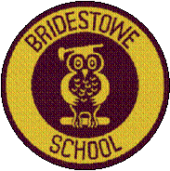 | Head of School: Miss Amy Scrivener  Administrator: Mrs Melanie Ford  01837 861361  www.bridestowe-primary.devon.sch.uk Executive Principal: Mr D.Chapman  Head of Primary: Mr M.Brady  Spring Week 5: February 5th 2016
Bridestowe Primary School | Dear Parents and Carers,  We have had a fantastic week at Bridestowe, kicked off with the sponsored skip. Look out for your children in the Okehampton Times! The morning began with sunshine but unfortunately the rain came once the children started skipping. However, this did not put them off which shows just how determined and resilient they are! Thank you to all the parents that came to support the children and to all of you that helped your child to collect sponsorship money. The School Councillors will send a letter out shortly informing you of how much was raised for the British Heart Foundation. If possible, please could we have all sponsorship money in by Friday 12th February?  A huge thank you to Rob Dugard for volunteering to work with the Snowy Owls and Barn Owls children. They have all thoroughly enjoyed the sessions this week and can’t wait to be taught by him again next week. On Thursday there will be a tag rugby lesson from 12.45pm-1.15pm for years 3,4,5 and 6. Please return the slip on separate letter if you wish your child to take part.  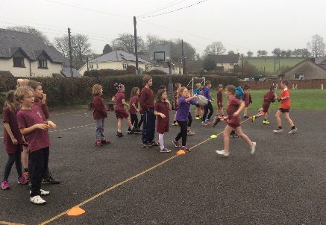  Best wishes,  Amy Scrivener
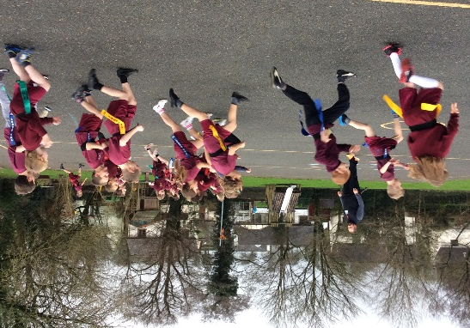
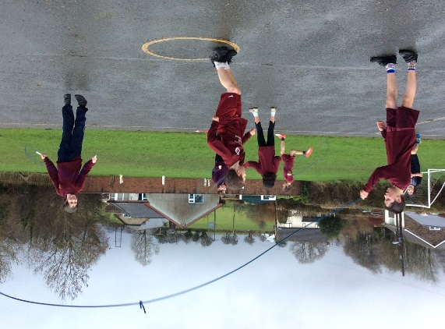
Achievement
Care and Courtesy Cup Winners:

Worker Award:

Behaviour Award:

Sports Award:

Extra Awards:
Writing Award: Maths Award:
Reading Award: Art Award:
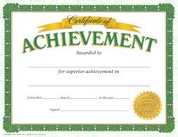
Pen Licence
Evie-Sue Ley, Grace Bird and Freya King
Top Table Winners:
Team Point Winners:

Diary Dates  February  1st – NO NETBALL CLUB  2nd – Sponsored Skip  2nd – Rotary Quiz, 6pm  3rd – Parent Forum @ 7.30pm in the Barn Owls  4th – Federation Football/Netball Match  8th – Netball Competition  10th – 8pm Quiz @ White Hart in aid of FoBS and Bridestowe School  11th – Federation Football/Netball Match  15th – 21st HALF TERM  22nd – NON-PUPIL DAY  23rd – Pupils Resume  23rd – X Country at Castle Drogo  29th – Football Competition  March  10th – Y6 Transition Visit from Okehampton College  25th – BANK HOLIDAY  28th – 11th EASTER HOLIDAYS  April  11th – NON-PUPIL DAY  12th – Pupils Resume | Parent Volunteers  If you have a skill or a job which you think will benefit the children or that you want to become involved in our school in any way, for example, listening to children read on a regular basis. Please contact myself or your class teacher to discuss this.
Lost Clothing
If your child has come home with a different shirt or piece of clothing please let your class teacher or Mrs Ford know. We have had some parents come to us with items of clothing that are not their child’s but would appreciate getting theirs back.
Reminder
Please ensure your child has got a jumper and winter coat with them at school throughout these winter months. We encourage them to go outdoors as much as possible.
Rotary Quiz
Some of the Barn Owls pupils attended the Rotary Quiz at Okehampton Primary on Tuesday. Two teams took part and thoroughly enjoyed representing the school.
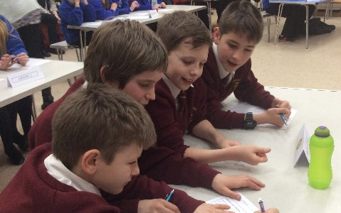

Parent Forum
The parent forum was a success, we had some lovely compliments from the parents who attended. These ranged from the pupils enjoying swimming lessons more than they ever have before, the pantomime trip as being enjoyable and valuable for the children and a recognition in the fantastic behaviour and cooperation between pupils was noted. The minutes will be sent to you shortly along with the safeguarding presentation that I gave. If you wish for any more information on this then please do not hesitate to contact myself or Hayley.

