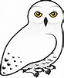

SNOWIES HOME LEARNING
Summer 1st Half 2016

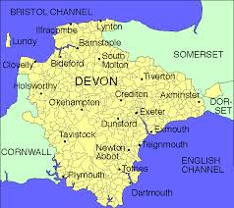
Our topics for this term are ‘Plants’ in Science and ‘our local area’ for both History and Geography. The regular activities are to be completed by all children. We ask all children to complete the core task and bring it to school on Friday 27th May to share with each other. The optional activities are a list of suggestions that you can do at home if you wish. They can be done at any time. Spellings and Times Tables will continue to be tested every Friday morning and the Mental Maths will be tested each Monday.

Core task

Challenge: Our local area
Can you find some facts about our local area (Bridestowe, Dartmoor, Okehampton etc) from the present day or maybe historical information?
Show your findings in any way you wish (photos, posters, models, leaflets etc.) but please make sure you use your own words to show that you understand and can teach someone else.
Regular activities to do at home
- Reading books. We expect children to read as much as possible and would like to see their books being changed on a regular basis. Please comment in their reading record, preferably related to their current target which is on the, ‘I can…’ sticker.
- Weekly spellings and write two sentences for the final two.
- Practise for weekly mental maths
- Weekly times tables

Optional Activities
- Create your own shape poem about plants and decorate it.
- Make a map of the Okehampton area and label some human and physical features. (Make a key)
- Create some Maths challenge word problems using 2 digit numbers (yr 2) and 3 digit numbers (Y3)
* remember to make a separate answer sheet*
- Learn to tell the time to the nearest minute
- Use a clock with Roman numerals
On-line Optional activities
(See reading record for passwords)

- RM Maths
- ‘SPAG.com’
- ‘Times Tables Rock Stars’

