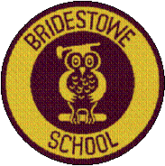

Head of School: Miss A.Scrivener Executive Principal: Mr D.Chapman
Head of Primary: Mr M.Brady

Dear parents and children of Bridestowe Primary School,
We would to thank you for your support with our recent fundraising. During our Remembrance fundraising we raised …….. by selling poppies, band etc.
We were amazed by the effort all the children went to by dressing up for Children in Need, all the children looked great and they all really enjoyed themselves. The cakes that were donated were fabulous and very yummy, the children really enjoyed eating these delicious cakes at break time and after school. In total we raised £123.60 for Children in Need. We were even photographed by the local newspaper the Okehampton Times!
A big thank you to you all for your effort with our fundraising.
Remember, our next event is the Christmas jumper day on Friday 18th December. These can be homemade jumpers with the children’s own designs or can be ones you have purchased. We ask for a minimum donation of 50p which will go to children’s charities.
Thank you.
From
The School Council.

