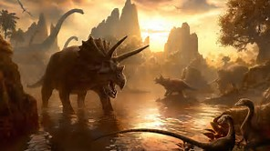OWLETS HOME LEARNING - Dinosaurs
The regular activities are to be completed by all children. The spellings will continue to be tested every Friday morning and the mental maths will be tested on Tuesday mornings. The practise sheets will be in their homework books each week. We ask all children to complete the core task and bring it to school by Thursday 14th December. The optional activities are a list of suggestions that you can do at home if you wish. They can be done at any time and we do not require these to be handed in, although if your child would like to show their work please feel free to bring it to school on any Monday. Their work will be shared with the class and the children will receive team points for completing them. If your child would like to bring in show and tell then please ensure it relates to the topic.
Optional activities
- Write a letter to Santa.
- Create a firework picture.
- Go for a walk and find four different leaves.
- Bring your favourite story to school and tell us about it.
- Get some pasta and make two groups then add them together.
Core task
Challenge:
Your task this half term is to make a model of a dinosaur. This could be from junk modelling, paper mache or Lego.

Regular activities to do at home
- Reading books. We expect children to read as much as possible and would like to see their books being changed at least 3 times a week. Please comment in their reading record, preferably related to their current targets.
- Mental Maths
- Spellings
- RM Easi Maths
- On a Wednesday children need welly boots.

